Art & Design Technology  Art, craft and design embody some of the highest forms of human creativity. A high-quality art and design education should engage, inspire and challenge pupils, equipping them with the knowledge and skills to experiment, invent and create their own works of art, craft and design.  Pupils should be taught:  - to use a range of techniques to record their observations in sketchbooks, journals and other media as a basis for exploring their ideas  - to use a range of techniques and media, including painting  - to increase their proficiency in the handling of different materials  - to analyse and evaluate their own work, and that of others, in order to strengthen the visual impact or applications of their work  - about the history of art, craft, design and architecture, including periods, styles and major movements from ancient times up to the present day  Defining the Elements  Have you ever looked at an artwork and wondered how the artist decided to begin making it? All art, whether two-dimensional like a painting or three-dimensional like a sculpture, contains one or more of the seven elements of art. These elements are:  - Line  - Color  - Shape  - Form  - Value  - Space  - Texture  They are the basic building blocks of making art.  Using the Elements  Let's say you are the artist. You've decided to create a drawing using a pencil on a white piece of paper. You might use the pencil to create the drawing using lines. A line is an element of art. It is a mark made upon a surface. In order to be a line, the mark's length must be longer than its width. There are many different types of lines, including horizontal, vertical, wavy, diagonal, and more. |  | 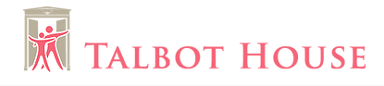  Art Department
 |  |  |  | A guide to help you support your children in Art and Design
 |  |  |  | How to draw a portrait
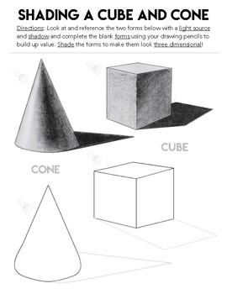
Shape- Shape is the result of closed lines, they are two dimensional and flat. Shapes can be geometric, such as squares or triangles or they can be organic and not have defined parameters and are more curved and abstract. Shapes in art can be used to control how the viewer perceives a piece.
Texture- Texture is how an object looks or feels. Sometimes texture can actually felt, such as in sculpture or the texture of work can be implied such as if you were to sketch a sheep’s wool. Some words to describe texture include soft, hard, rough, brittle, fluffy, or smooth.
Space- Space is any area an artist creates for a specific purpose. Space can be positive or negative. Positive space is an area occupied by an object or form. Negative space is the area that runs between, through, and around or within objects. This includes background, foreground, and middle ground. Space that can be manipulated in art based on how an artist uses lines, shape, form, and colour.
Form- When shape acquires depth and becomes three dimensional, it takes on form. Three-dimensional art has an actual form (like in architecture) while two-dimensional pieces can have the illusion of form when the artist uses perspective or shading. Some common forms are cones, pyramids, spheres, and cubes.
Value- Value is the lightness or darkness in color. The lightest value is white and the darkest value is black. The difference between values is contrast. You can study the use of value in monochromatic or black and white pieces of art.

Homework &

Home learning
Be sure to ask your children about their homework/ home learning. Find out what they are learning. Keep a calendar of projects and upcoming tests. The more you know about what is going on, the more you can help them stay on task. Make sure when you help a child with a homework problem, you guide them through, not do the work for them. See if they know what steps to take next instead of taking over.

Annotations are written explanations or critical comments added to art or design work that record and communicate your thoughts.
 |  |  |  | 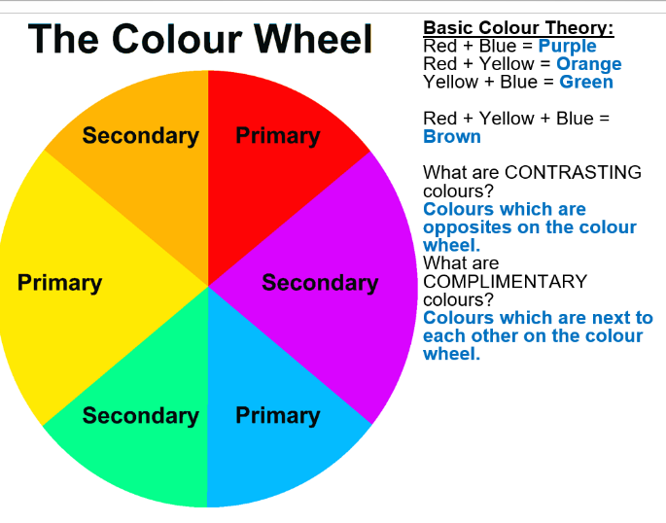
Annotating your work  What media and materials have you used?  What processes or techniques have you used?  What effects have you used?  What could this medium/ material/ techniques/effect be used for?  What are your opinions about the work?  Could it be improved or developed in any way? |  |  |  | Analysing Art Work  What formal elements have been used?  I.e. Line, Tone, Shade, form, shape, texture or pattern  What materials, techniques and processes have been used?  What is the context of the work ?  What were the artist’s intentions?  What are your personal opinions/comments/feelings about the work?  Evaluation Questions  Describe the outcome that you have produced  What work did you need to do before you could produce it?  Where did you get the idea for it?  What materials did you use?  What processes/techniques did you use?  What new skills have you learned?  What new knowledge have you gained?  What would you change about you work if you had to start again?  What is the best thing about this piece of work?

